Alcohol Use in New Mexico
Alcoholic Liver Disease

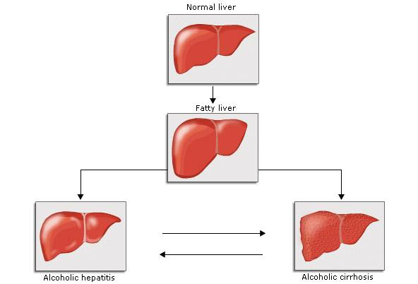

New Mexico Statewide Epidemiological Outcomes Workgroup
White Paper Series

November 16, 2017
Produced by Coop Consulting, Inc. on behalf of the
New Mexico Statewide Epidemiological Outcomes Workgroup
Mission New Mexico’s Statewide Epidemiological and Outcomes Workgroup (SEOW) reviews and disseminates data about substance abuse and misuse and their consequences. It also identifies best practice information about evidence-based prevention strategies, policies and practices that can lead to successful outcomes for New Mexicans. The purpose of this two-fold work is to inform communities so that they can better target behaviors and risk factors that can be positively impacted by the implementation of well-chosen, evidence-based prevention approaches that are appropriate for the population. The important work of the SEOW is directed by the Office of Substance Abuse Prevention (Behavioral Health Services Division, Human Services Department) and supported by federal funding from the Center for Substance Abuse Prevention, Substance Abuse and Mental Health Services Administration.

Statewide Epidemiology and Outcomes Workgroup (SEOW) Members
BHSD Office of Substance Abuse Prevention  Karen Cheman, Prevention Director,  NPN & SEOW Director  Heather Burnham, Program Manager  Antonette Silva-Jose, Program Manager  Anwar Walker, Program Manager | Behavioral Health Services Division (BHSD)  Wayne Lindstrom, Ph.D., Director and CEO, Behavioral Health Collaborative  Mika Tari, Deputy Director  Tiffany Wynn, Clinical Services Director
Department of Finance and Administration  Julie Krupcale, DWI Bureau Chief | Children Youth and Families Department, Behavioral Health Services  Michael Hock, Program Manager
DOH Epidemiology and Response Division  Jim Davis, Epidemiologist  Dan Green, Epidemiologist  Kathryn Lowerre, Program Evaluator  Ihsan Mahdi, Epidemiologist  Annaliese Mayette, Epidemiologist  Carol Moss, Epidemiologist  Luigi Garcia Saavedra, Epidemiologist  Laura Tomedi, Epidemiologist | Community Members*  Ann DelVecchio, Owner, Alpha Assessment Associates  Shelley Moeller, Program Planner & Evaluator, M&O Consulting  John Steiner, Program Manager, UNM CASAA/COSAP  Sharz Weeks, Program Specialist, Bernalillo County Community Health Council
Pacific Institute for Research & Evaluation (PIRE), NM State Level Evaluator  Liz Lilliott, Ph.D  Martha Waller, Ph.D  Lei Zhang, Ph.D | Coop Consulting, Inc., Project Staff  Michael Coop  Andrea Niehaus  Tina Ruiz  Tim Werwath
*Community preventionists across the state attend and contribute using the SEOW as a resource for work in the larger New Mexico prevention system. For more information, contact Karen Cheman, karen.cheman@state.nm.us or Michael Coop, michaelcoop@newmexico.com.

Introduction

Alcohol consumption is high in most Western countries, although the United States ranks far below others such as France, Germany, and the United Kingdom. Nevertheless, the 2015 National Survey of Drug Use and Health estimates that nearly 15 million Americans have an alcohol use disorder. In this paper, we explore the leading cause of death from excessive alcohol use, alcoholic liver disease.

What is alcoholic liver disease, and how prevalent is it?

Alcoholic liver disease is a term that encompasses the liver manifestations of excessive alcohol use. These manifestations generally occur on a spectrum, and include:

- Fatty liver – a condition in which fat accumulates in liver cells due to the production of toxins in the liver during the metabolism of alcohol. It occurs in approximately 90% or more of alcohol abusers. Although generally considered benign and reversible through abstinence, it is the first step towards developing liver disease.
- Hepatitis – acute inflammation of the liver due to excessive alcohol consumption, considered a reaction to liver cells affected by fatty deposits. It occurs in approximately 10 to 35% of alcohol abusers, and is considered an early state of alcoholic liver disease.
- Cirrhosis – the replacement of normal liver tissue by scar tissue due to repeated injury caused by long-term excessive alcohol use. This scar tissue disrupts the normal function of the liver by interfering with blood flow through the organ. Cirrhosis develops in 10 to 20% of individuals who abuse alcohol for a decade or more.

What are the risk factors for alcoholic liver disease?

In general, the greater amount and longer duration of alcohol use the more likely alcoholic liver disease will occur. However, the amount of alcohol consumed before liver damage occurs is extremely variable, with some people being extremely sensitive to the effects of alcohol, with others being less vulnerable to its harmful effects. On average, having six or more drinks of alcohol daily will lead to cirrhosis of the liver in 10 years for men and 5 years for women.

It is unknown why women are more susceptible to alcoholic liver disease than men. Even when adjusted for body size, women are still at a greater risk for liver damage at lower quantities of alcohol. It is theorized that differences in fat absorption and digestive enzymes may account for this phenomenon.
Other known risk factors for alcoholic liver disease include:
- Genetic factors – genetics predispose individuals to both alcoholism and the risk of developing alcoholic liver disease. Genetic differences in the production of digestive enzymes involved in the metabolism of alcohol may explain why this is true.
- Diet – drinking outside of meal times increases the risk of alcoholic liver disease by nearly three times. Furthermore, vitamin deficiencies caused by malnutrition can worsen liver damage by inhibiting the regeneration of liver cells.
What is the prevalence of and what are the trends in alcoholic liver disease-related deaths?
In 2013, liver cirrhosis was the 12th leading cause of death in the United States, with a total of 37,890 deaths. Nationwide, the death rate from alcohol-related liver cirrhosis increased by 18.6 percent between 2000 and 2013, from 4.3 deaths per 100,000 population to 5.1 deaths per 100,000 population. Rates increased the most for White males (19%), White females (50%), and individuals aged 25-34 (55%).
The figures below show the leading causes of alcohol-related death and trends in alcohol-related death in New Mexico, courtesy of the New Mexico Department of Health Epidemiology and Response Division.
Figure 1. Alcohol-related death by year in New Mexico and the United States, 1990-2015

Source: New Mexico Department of Health, Epidemiology and Response Division. All rates are per 100,000, age-adjusted to the 2000 US standard population.
Figure 1 indicates that there was a steady increase in the total number of alcohol-related deaths in the 1990s and 2000s. Since 2010, there has been a sharp increase in the number of alcohol-related deaths, which is being largely driven by increases in alcoholic liver disease-related deaths. Between 2010 and 2015, deaths from alcoholic liver disease in New Mexico increased by 56%, from 23.0 per 100,000 population to 35.8 per 100,000 population.
Figure 2. Alcohol-related death by cause of death, 2011-2015

Source: New Mexico Department of Health, Epidemiology and Response Division

Figure 2 shows that alcoholic liver disease accounts for approximately one in four alcohol-related deaths in New Mexico. Another 10% of deaths are from liver cirrhosis not directly attributed to alcoholic liver disease, and another 10% are from alcohol consumption mixed with other drug abuse.
Table 1 breaks down heavy drinking rates by age, sex, and race/ethnicity in New Mexico. Overall, men tend to have rates of alcoholic liver disease nearly double that of women (25.5 versus 13.3). Rates of heavy drinking are highest among American Indian men and women (80.9 and 52.2, respectively). The rate for American Indians as a whole are more than triple that of the statewide rate. With respect to age, rates of alcoholic liver disease are highest among individuals 25-64 (31.2).
Map 2 (see last page) shows the breakdown of alcoholic liver disease death rates by county in New Mexico. Alcoholic liver disease rates are highest in McKinley (61.0), Rio Arriba (58.8), and Cibola (43.8) counties. It should be noted that this is in contrast to rates of adult heavy drinking (not shown), which are highest in the southern counties of Hidalgo, Lincoln, and Socorro.

Table 1. Prevalence of alcoholic liver disease death in New Mexico by age, race/ethnicity, and gender, 2012-2016
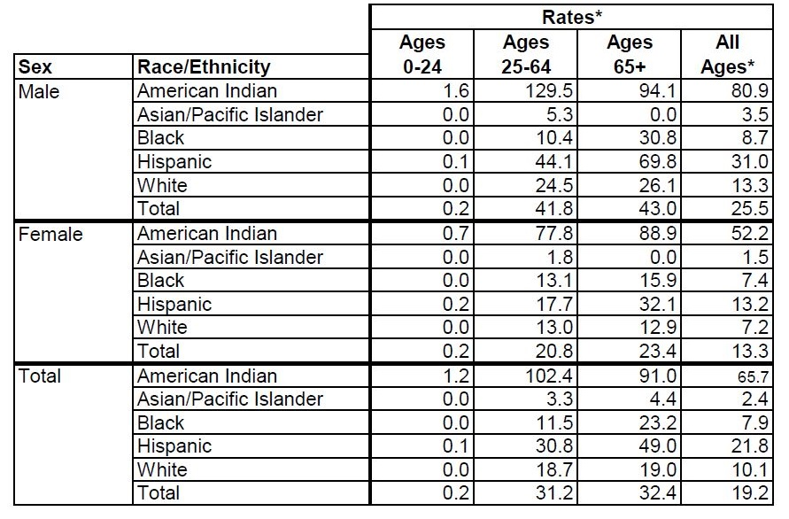
Source: New Mexico Department of Health, Epidemiology and Response Division. All rates are per 100,000, age-adjusted to the 2000 US standard population.

Conclusion
With the recent increase in alcoholic liver disease-related deaths in New Mexico happening concurrently with larger, long-term increase in alcohol-related liver cirrhosis nationwide, it is critical for public health efforts concerning alcohol to be properly informed about what it is, how it develops, and what the risk factors are for developing this disease. Such efforts may need to include broader public education campaigns about the risks of excessive alcohol consumption, the rates of death from alcoholic liver disease, and treatment options for individuals with an alcohol use disorder.

Map 1. Prevalence of alcoholic liver disease death in New Mexico by county, 2012-2016
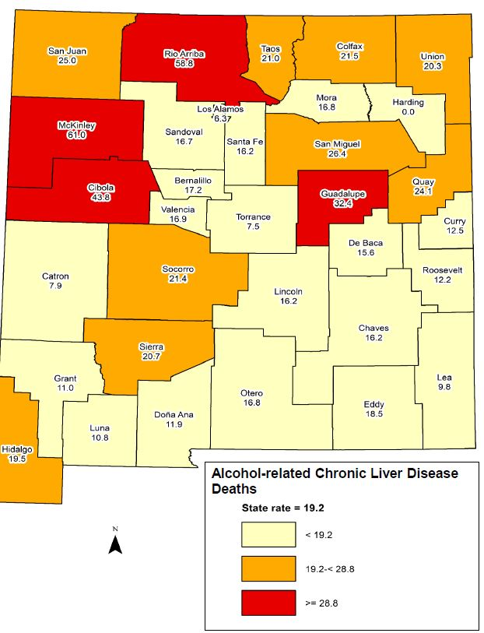
Source: New Mexico Department of Health, Epidemiology and Response Division. All rates are per 100,000, age-adjusted to the 2000 US standard population.

World Health Organization. Global Status Report on Alcohol and Health, 2014.
Substance Abuse and Mental Health Services Administration, 2015-2016 National Survey of Drug Use and Health.
American College of Gastroenterology, Alcoholic Liver Disease: A Consumer Health Guide, 2010.
Mayo Clinic, Pathogenesis, Diagnosis, and Treatment of Alcoholic Liver Disease, 2001.
Mayo Clinic, Pathogenesis, Diagnosis, and Treatment of Alcoholic Liver Disease, 2001.
Yoon, Y. H., C. M. Chen, and H. Y. Yi. "Liver cirrhosis mortality in the United States: National, State, and Regional Trends, 2000-2011." NIAAA Surveillance Report #105, 2016.

